

**University Management System**

**This document is submitted for Database Systems project, by:**

**Ebrahim Ramadan – 320220029 (Team Leader)**

**Momen Hesham – 320220060**

**Ahmed Hamed– 320230024**

**Renada Tamer – 320230143**

**Youssef Kamal - 320220025**

**Under supervision of /**

**Business and System Requirements Specification**

**1. Key Stakeholders**

**1.1 Students Requirements:**

**- Personal profile management (NID, Name, Email, Address)**

**- Academic record access and management**

**- Course registration and tracking**

**- Access to transcripts and GPA information**

**- Library loan management**

**- Research assistant role management**

**- Attendance tracking**

**- Academic advisory services**

**- Club membership management**

**1.2 Academic Staff**

**Professors Requirements:**

**- Profile management (Name, NationalID, Email)**

**- Department affiliation management**

**- Course teaching assignments**

**- Research project supervision**

**- Faculty relationship management**

**- Professional ID management**

**Instructors Requirements:**

**- Profile management (NationalID, Email)**

**- Course teaching assignments**

**- Department affiliation**

**- Office hour management**

**1.3 Administrative Entities**

**Department Management Requirements:**

**- Department information management**

**- Staff assignment management**

**- Building and room allocation**

**- Course offering management**

**- Faculty relationship management**

**Faculty Administration Requirements:**

**- Faculty profile management**

**- Department oversight**

**- Research project management**

**- Staff allocation**

**- Resource management**

**1.4 Facility Management**

**Building Management Requirements:**

**- Building information management**

**- Room allocation and tracking**

**- Capacity management**

**- Equipment tracking**

**2. System Requirements**

**2.1 Academic Management**

**Course Management Requirements:**

**- Course creation and updates**

**- Prerequisites management**

**- Grade tracking**

**- Course Code management**

**- Credit hour tracking**

**- Course material management**

**Examination System Requirements:**

**- Exam scheduling**

**- Score recording**

**- Weight management**

**- Exam type classification**

**- Duration tracking**

**Transcript Management Requirements:**

**- GPA calculation**

**- Course history tracking**

**- Academic performance recording**

**- Semester-wise grade management**

**2.2 Administrative Functions**

**Attendance System Requirements:**

**- Student attendance tracking**

**- Attendance date recording**

**- Attendance status management**

**Library System Requirements:**

**- Loan management**

**- Due date tracking**

**- Book return status**

**- Fine management**

**Club Management Requirements:**

**- Club membership tracking**

**- Student participation records**

**- Club activity management**

**2.3 Research Management**

**Research Projects Requirements:**

**- Project tracking**

**- Student assistant assignment**

**- Faculty supervision**

**- Project status management**

**- Timeline management**

ERD

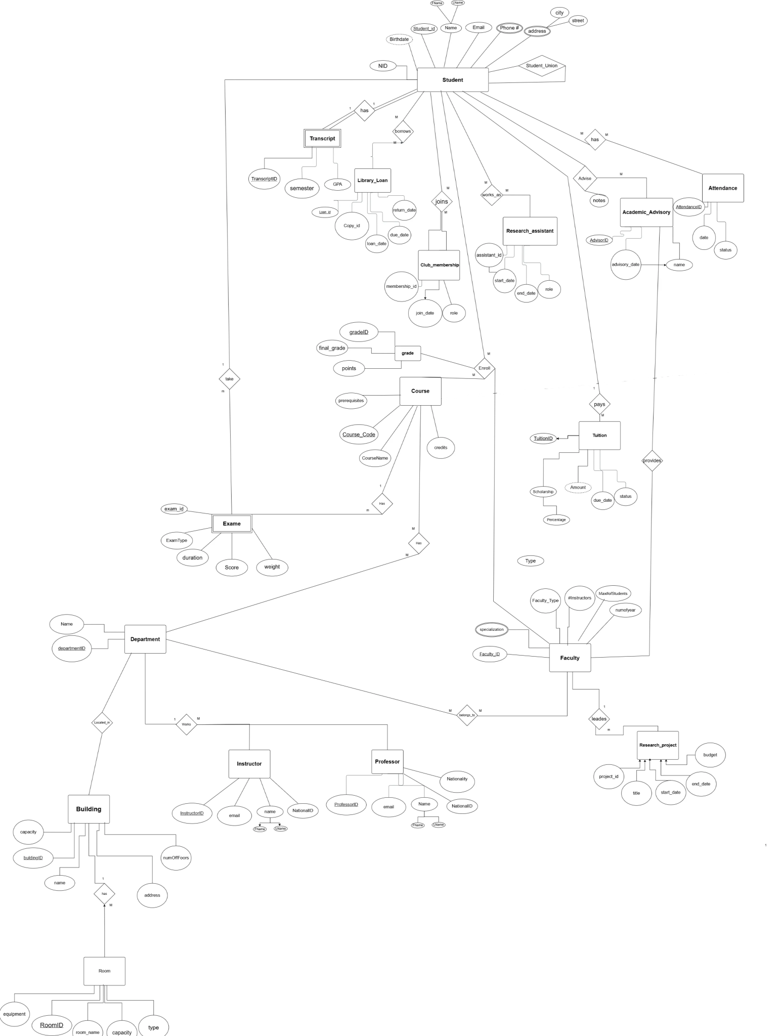

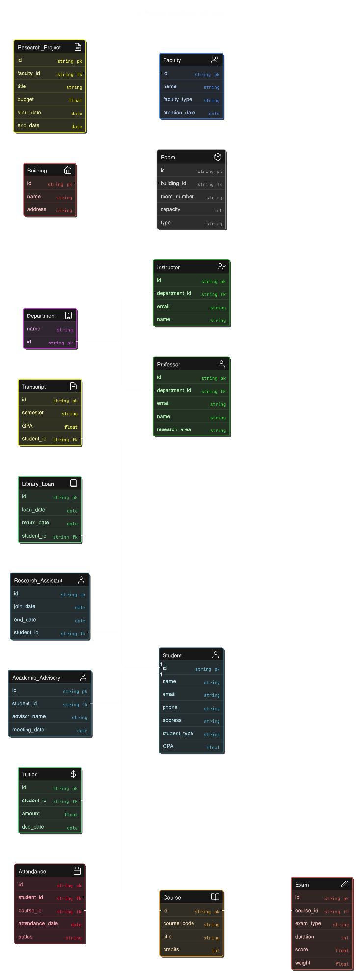

Schema

Data Dictionary

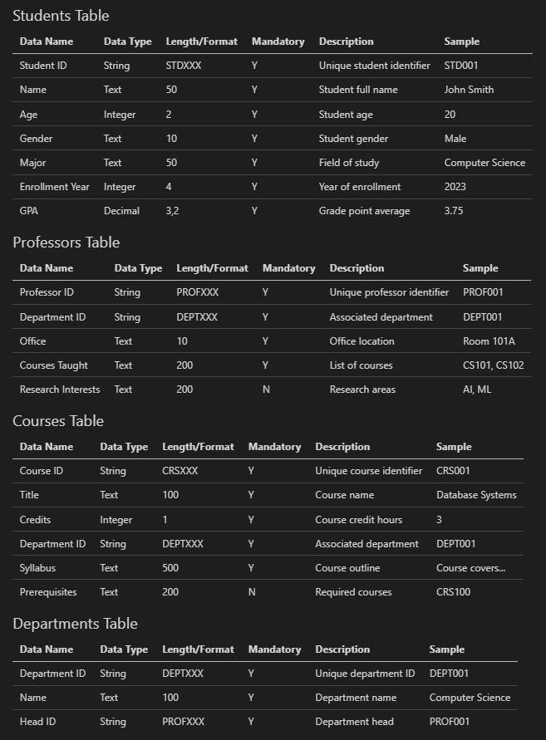

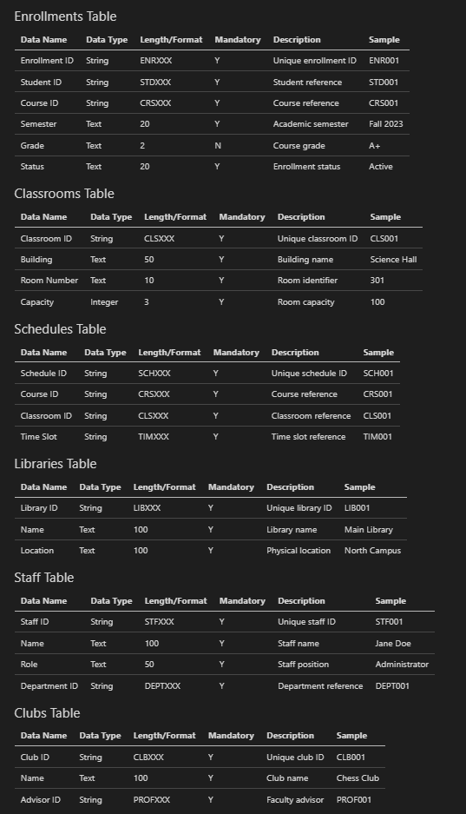

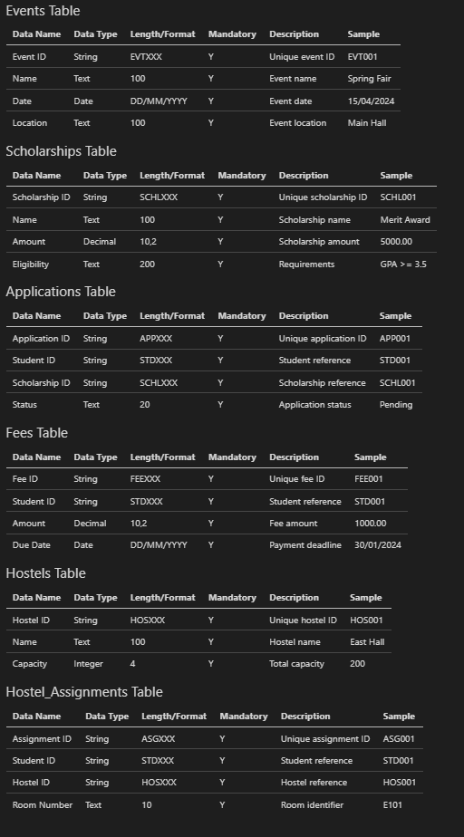

DQL / RA

SQL queries and Relational Algebra

1- Advisor Information Retrieval

ADVISOR_INFO ← π[academic_advisor_id, name, student_id, email](academic_advisors)

2-Student Information Retrieval

STUDENT_INFO ← π[student_id, enrollment_year, name, major, age, gpa, email, faculty_id](students)

3-Students Information by Specific Faculty (Faculty ID 2)

STUDENT_FACULTY ← (students ⋈students.faculty_id=faculty.faculty_id faculty)

RESULT_3 ← π[student_id, enrollment_year, name, major, age, gpa, email, faculty.name](σ[faculty_id=2](STUDENT_FACULTY))

FACULTY_PROFESSORS ← (professor ⋈professor.professor_id=professor_faculty.professor_id professor_faculty)

RESULT_4 ← π[professor_id, name, email, nationalID](σ[faculty_id=1](FACULTY_PROFESSORS))

SINGLE_STUDENT ← π[student_id, enrollment_year, name, major, age, gpa, email](σ[student_id=10](students))

PROF_FACULTIES ← (professor_faculty ⋈professor_faculty.faculty_id=faculty.faculty_id faculty)

RESULT_6 ← π[faculty.name](σ[professor_id=5](PROF_FACULTIES))

PROF_COUNT ← G[professor_id]COUNT(faculty_id)->faculty_count(σ[COUNT(faculty_id)>0](professor_faculty))

ALL_COMBINATIONS ← (professor ⋈p.professor_id=pf.professor_id AND f.faculty_id=pf.faculty_id faculty)

RESULT_8 ← π[professor.name, faculty.name](σ[pf.professor_id IS NULL](ALL_COMBINATIONS))

PROF_FAC_FULL ← ((professor ⋈professor.professor_id=professor_faculty.professor_id professor_faculty)⋈professor_faculty.faculty_id=faculty.faculty_id faculty)

RESULT_9 ← π[professor.name, faculty.name](PROF_FAC_FULL)

ADVISOR_STUDENTS ← (academic_advisors ⋈aa.academic_advisor_id=students.academic_advisor_id students)

RESULT_10 ← π[aa.academic_advisor_id, aa.name->advisor_name, s.student_id, s.name->student_name](ADVISOR_STUDENTS)

ADVISORS_NO_STUDENTS ← (academic_advisors ⋈aa.academic_advisor_id=students.academic_advisor_id students)

RESULT_11 ← π[aa.academic_advisor_id, aa.name->advisor_name](σ[s.student_id IS NULL](ADVISORS_NO_STUDENTS))

ADVISOR_COUNT ← (academic_advisors ⋈aa.academic_advisor_id=students.academic_advisor_id students)

RESULT_12 ← G[aa.academic_advisor_id, aa.name]COUNT(s.student_id)->student_count(ADVISOR_COUNT)